

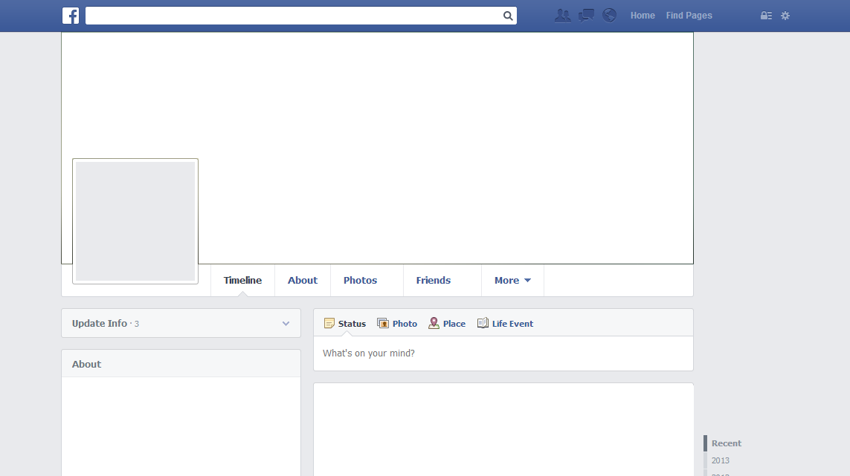

**Kyle**

Works at:

UNIVERSITY OF GLOUCESTERSHIRE as Lecture Assistant.

Likes:

Kyle

February 23rd at 14:36 PM

Totally agree with the Radio Times here! Regardless of age Doctor Who is a wonderful show for everyone who watches and will stay relevant for a long time to come!!

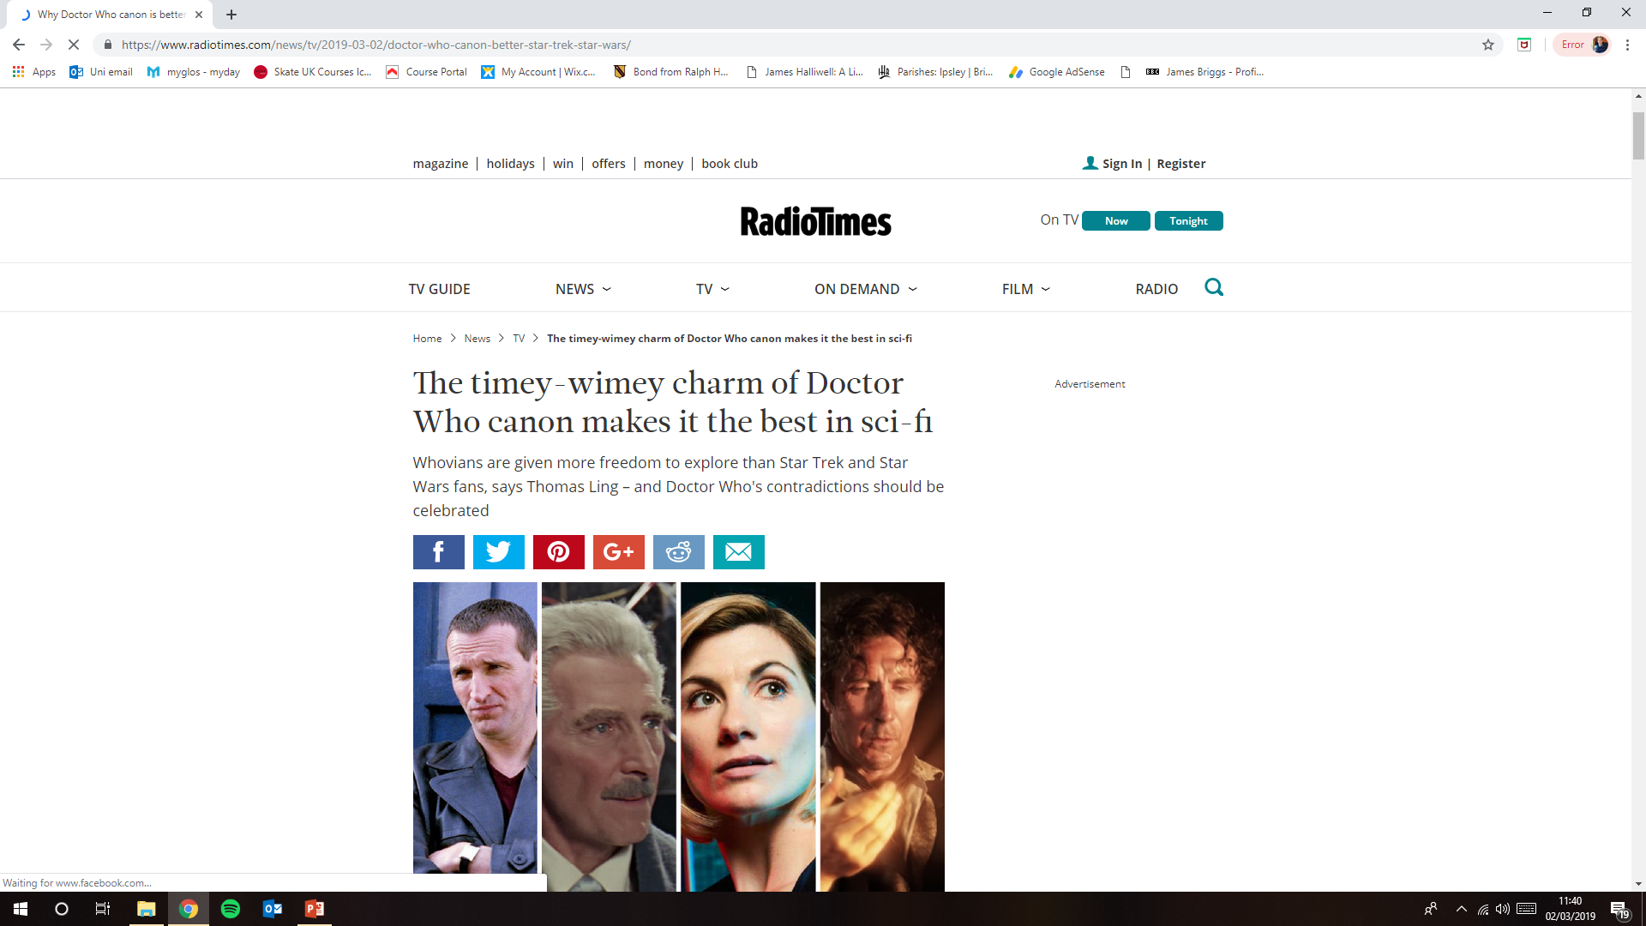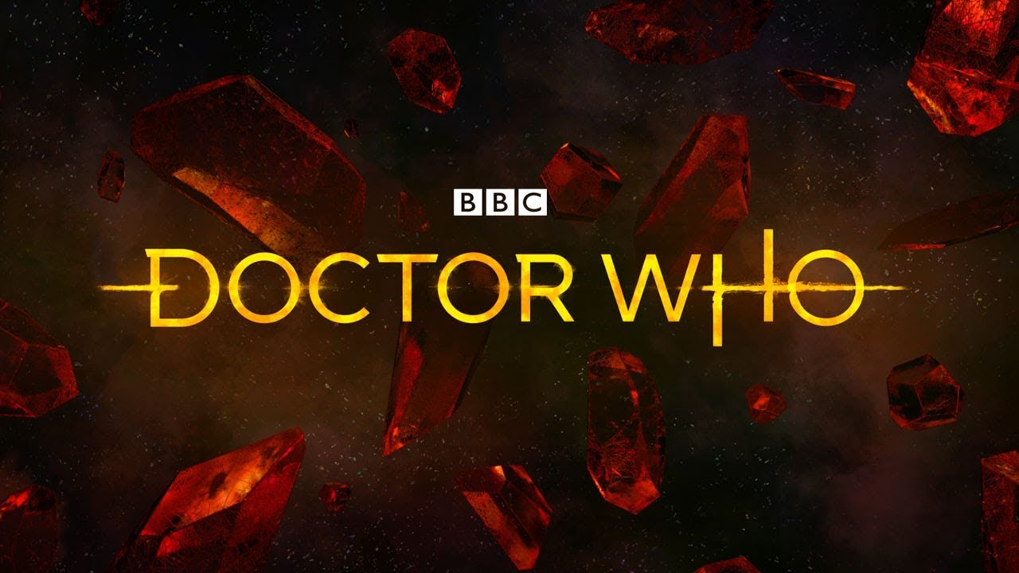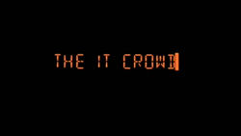

Send

Attach

To:

Subject:

From:



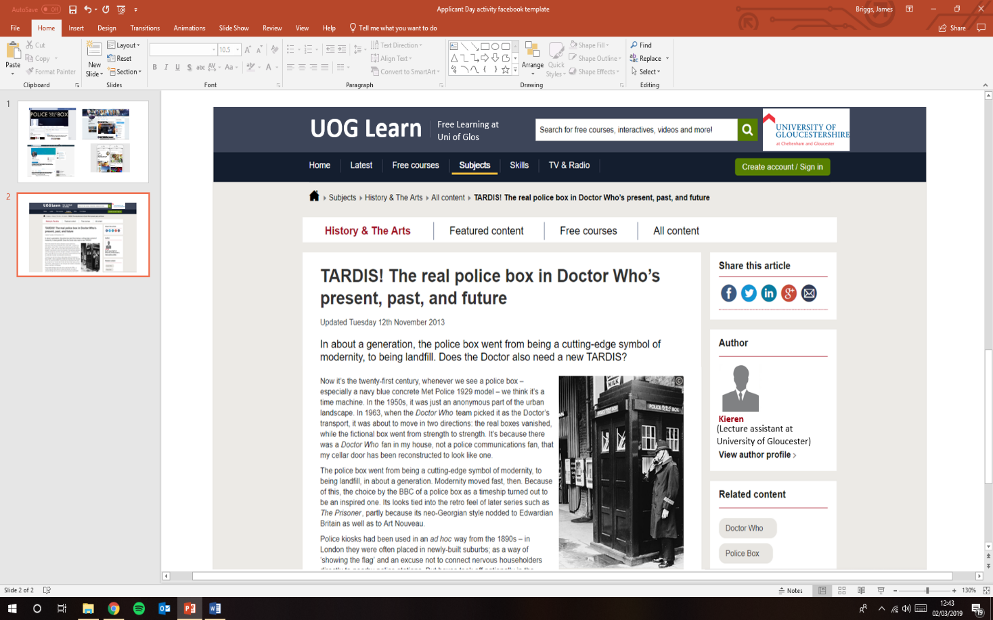

**Kyle**